Western Renewables Link
Submission to Environment Effects Statement from Ken McDonald, Chairman of the Coimadai Avenue of Honour Restoration Society Inc.

The Coimadai Avenue of Honour has 133 trees planted along the Coimadai-Diggers Rest Road for approximately 1.3 kilometers on the Northern side of the road and 300 meters on the Southern side. These trees commemorate 129 volunteers from the area who went to World War 1, plus 4 markers. In addition to the Avenue and approximately 300 meters from the Eastern end, the Coimadai Memorial Park is situated within the Southern Rural Water picnic ground, adjacent to Merrimu Reservoir. The Avenue was first planted in 1915 in the township of Coimadai, the area of which now lies under the waters of Merrimu. The contribution that Coimadai citizens made to the war was quite outstanding. When volunteers were sought, 128 men and one woman from Coimadai volunteered for World War 1. Coimadai then included the municipalities of Merrimu, Long Forest and part of Darley. The census of 1911 showed that there were 404 citizens in Coimadai, yet one third of those citizens on the roll, volunteered to go to war on the other side of the world to safeguard the community back home. This WW1 contribution was a remarkable feat of patriotism, most unlikely to be repeated today. But we remember these sacrifices that our ancestors deeds, at least twice yearly on Anzac and Remembrance Days, this is our spirit and we are reminded that the deeds of these volunteers was not in vain. The Avenue of Honour includes one marked tree for every volunteer and the Park includes a story on the war effort and a tribute to the 32 volunteers who did not return.
The Avenue was first planted in 1915, but when the Merrimu Reservoir was constructed in 1967, by the then State Rivers and Water Supply Commission, they, in conjunction with the Shire of Bacchus Marsh, knocked the Avenue down and replanted trees along the Coimadai-Diggers Rest Road, using pine tree saplings. All saplings were stolen the first Christmas. The authorities then planted Cyprus trees which were totally unsuitable for the area, with most dying or being stunted in growth. Approaching the centenary of the first planting, the residents of Coimadai decided that the Avenue should be properly restored. There were less than a dozen trees, from the hundred or so planted 50 years earlier and only three taller than 3 meters. The earlier works by the Council included the construction of a cairn, which was situated on the Coimadai-Diggers Rest Road. Vic Roads had advised the community that the cairn could no longer be used for services or memorials due to its dangerous location, so the community resolved to replant the trees of a suitable variety and shift the cairn to a safer location.
Discussions were held with Southern Rural Water, managers of the reservoir and an area was agreed to be permanently leased and designated as The Coimadai Memorial Park. Fund raising commenced and volunteers of labour and equipment sought to undertake these works. The job was completed and an official opening occurred on the 27th June 2015, with almost 1,000 people in attendance. The Coimadai Avenue of Honour, symbolizing a supreme volunteer effort for the Great War, has now been planted four times and it is at risk from State Government instrumentalities, again, with the Transmission Line being constructed over the full length of the Avenue and an Eastern Link Diversion Road being built, causing the removal (replacement?) of 36 Avenue trees. In the opinion of Coimadai citizens, the Coimadai Memorials are very significant and must not suffer interference, particularly where it seems avoidable. If the Transmission Line is constructed according to the draft plan, the 80 meter towers along its full length will totally overpower the vista of an Avenue, some trees are within the easement and may require pruning or relocating and the view from the Memorial Park will be dominated by transmission towers in the Avenue and the passage across Merrimu Reservoir. There would seem to be a dozen towers in the section of Coimadai-Diggers Rest Road between Long Forest Road and Bacchus Marsh-Gisborne Road, a very sizable blotch on the vista of the Avenue, the neighborhood and the suburb generally. The EES Map Book provided, shows the proposed location of towers on page 67, but does not recognize the location of trees in the Avenue of Honour, so it is difficult for us to determine the precise impact on the trees within the easement. The easement seems to encompass most of the Avenue West of the Memorial Park.
There is a question about the easement itself, with the Landholder Guide Easement Safety and Permitted Activities showing on Page 4 that the easement is 70-100 meters wide, but the EES Summary Report states that the route is 100-170 meters wide. We would like some clarification on these sizes, as the larger section will have a huge detrimental effect on the Avenue of Honour. As explained, the Avenue of Honour belongs to the citizens of Coimadai, as does the Coimadai Memorial Park. The Coimadai-Diggers Rest Road is owned by Vic Roads and managed by the Shire of Moorabool. The Park is covered by a formal lease agreement with Southern Rural Water but the Avenue itself is without any such agreement. The Avenue trees have been planted since 1967 and the full co-operation and approval of the Council and Vic Roads has been granted to The Coimadai Avenue of Honour Restoration Association Inc for their activities and maintenance program. The Association does its own fundraising to cover the cost of these activities. If a tree were to be knocked down or otherwise damaged, the Association would be responsible for rectification. In terms of the Landholder Guide Option for Easement Process and Compensation, are we a “landholder” or a “stakeholder” and are we eligible for compensation as outlined in that guide?. If we need to have our situation legally clarified, are we eligible for assistance with legal fees? We would appreciate some clarity on this matter.
The following map, provided by Ausnet, shows in purple the revised route including a diversion over Merrimu Reservoir, presumably done to avoid intrusion into the Long Forest Conservation Zone. That attempt has not completely avoided the mallee scrub as the easement runs through woodlands East of the reservoir and again further East past the Djerriwarrh Creek. If tree height needs to be curtailed within the easement and access provided for massive vehicles conducting maintenance along the transmission line, this will have a substantial effect on the Avenue of Honour. We were informed at our on-site meeting with Ausnet that at least two trees at the Eastern end of the Line would be under the cables and might require trimming or relocating.
The Avenue of Honour was planted along the Coimadai-Diggers Rest Road, to utilize all of the available space from the Merrimu high water buffer zone to the East and the Bacchus Marsh-Gisborne Road to the West. The Southern side of the Coimadai-Diggers Rest Road includes the Powercor Distribution Line and prevents tree planting along one kilometer of that side. The marker plates for WW1 volunteers are arranged alphabetically so that the relocation of a few trees, or name plates (in the middle of the alphabet) is not a simple thing. Likewise, we cannot have some trees in the Avenue trimmed to 10-15 meters when the remainder are 15-20 meters high.
Merrimu Reservoir was constructed in 1967 and trees were planted at the time to shield vehicular disturbance along the tracks to the quarry, used for the reservoir wall construction. None of these trees, including eucalyptus, have grown above 20 meters in the difficult growing conditions of the Coimadai plain and we are very concerned about access tracks that need to be provided for tower maintenance along the easement. Our research into similar transmission lines in USA indicate that 80 meter towers are likely to require annual maintenance and replacement before 20 years. If native trees cannot reach full growing potential in the 60 years since 1967, how are shrubs, grasses etc, which maintain the lifestyles of the rare native fauna, going to survive the construction, constant maintenance and replacement of these monster towers. The easement itself is quite substantial, 70-100 meters wide, as advised. The Avenue of Honour is, say, 1.5 kilometers long, average 85 meters wide gives an easement total are of 1200-1300 hectares, and if you add in its effect on the Long Forest Conservation Zone Flora, you are looking at, say, 4000-5000 hectares affected by noise, dust, tree pruning, mowing and lack of aerial firefighting ability due to the tower proximity.
The Long Forest Conservation Zone is proclaimed for the area adjacent to Long Forest Road, however the typography stretches North past Merrimu to join up with the Pyrite State Forest and East over the Djerriwarrh Creek into Melton. This provides access for birds and animals that choose to select this unique environment as “home”. It is difficult to calculate the long term effect on the Long Forest fauna, except that there has been a continuous habitation of people and animals for a very long time, with a “canoe” tree being found in the bush near Long Forest Road. For further information please read “Long Forest mallee at the back door” by Friends of Werribee Gorge and Long Forest Mallee Inc, Jack’s Track Notes by Jack Myers or Birds of the Long Forest 1889-2005 by Hewish, Ward, Bugg and Munday. There are further papers researched by Michael Baker on the unique ants of Long Forest and presented to the Shire of Moorabool.
It seems to us that the planning has attempted to bypass the Conservation Zone by “kinking” the line over the reservoir. That objective has not been achieved with some intrusion into Long Forest and the unique typography, has created a new set of issues around Merrimu and the Coimadai Memorial Park. There is a connection between the forest in the Conservation Zone, North, East and West which provides the habitat corridor for thousands of hectares.
Memorial services held at the Coimadai Memorial Park for Anzac Day, Remembrance Day and other special occasions. These services will be dwarfed by 80 meter towers visible South and East of the Park, notwithstanding the effect of trees in the Avenue having to be pruned,(relocated), that are now planted in the easement. What seems logical to us, is to underground that section of the Transmission Line, avoiding the Conservation Zone and avoiding running the line over Merrimu Reservoir. This would provide a secondary benefit of allowing aircraft refilling from the Reservoir, no matter how low the water level might be reduced due to drought. It would also allow access to firefighting aircraft approaching from the vulnerable Northern Side of the Long Forest area.
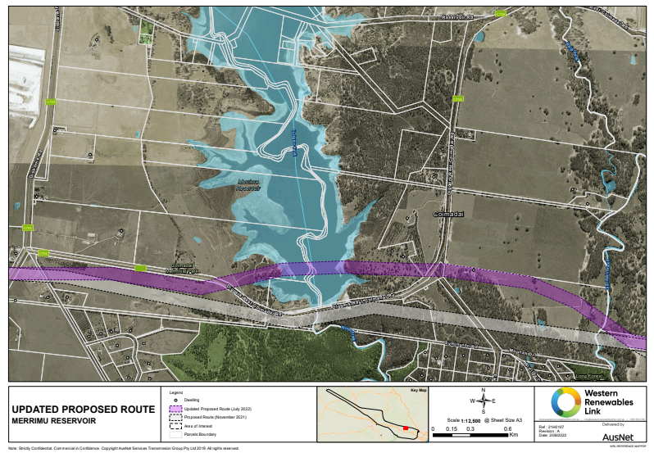,
The proposed route for the Transmission Line runs towers and cables the full length of the Coimadai Avenue of Honour with visual impact from these towers occurring over the whole Avenue and Coimadai Memorials Park. Our Association has been advised that a new Eastern Link road diversion is considered for the Western end of the Coimadai-Diggers Rest Road (see map below provided by Vic Roads) and that 36 Avenue might have to be relocated to facilitate a major roundabout and road diversion.
The map provided seems to show a clash between the proposed roadworks and the proposed Transmission Line easement. We were informed at a site meeting that the road project had not yet been funded as compared with the Transmission Line which has full status. Nevertheless, these are both projects that affect the Coimadai Avenue of Honour and will be both financed by the Government of Victoria. Vic Roads thought that their job would be completed within 5 years, commencing in 2023, and the Western Renewables Link by July 2027. It will be fairly crowded with machinery along the Coimadai-Diggers Rest Road if both of these project occur simultaneously.
We would encourage authorities to communicate with each other and to undertake their projects conjointly, where the Coimadai Avenue of Honour is involved. We have put the proposal to Ausnet, that in conjunction with the Eastern Link Road, a number, if not most, of the poles in the Powercor distribution line on the Southern side of the Coimadai-Diggers Rest Road, would need to be relocated due to the transmission line easement, or the Eastern Link roadworks. If these poles were moved say, 50 meters further South, or the Transmission Line undergrounded along this section, the Coimadai Avenue of Honour could be returned to being an “avenue” with trees on both sides of the road. We were informed that the North-South section of the Powecor distribution line adjacent to the Memorial Park would be replaced underground because of the Ausnet policy on crossing lines. This does not address the trees in the easement that might require relocation. The matter of pruning these trees is not acceptable to the Association. We have asked Ausnet for their view on shifting the Poercor line but we have not had a response regarding the remainder of the Powercor poles.
The Coimadai Memorial Park has been identified as an area of significance by your engineers and is mentioned on page 60 of your “Technical Report Social Impact Assessment”, as follows –
Coimadai Memorial Park and Avenue of Honor - Coimadai Memorial Park is located adjacent to the Merrimu Reservoir picnic area and includes a memorial garden, small pavilion and information boards commemorating the 129 volunteer service men and women from Coimadai who served in the World War I. ANZAC day services are held at the Memorial Park. Coimadai Avenue of Honour is located along Diggers Rest-Coimadai Road at the entrance to the memorial park and commemorates people from the district who served in World War I. The Avenue was replanted by community members in 2015 to replace the original Avenue that was lost under Merrimu Reservoir in 1967, with the current plantings comprising eucalypts. The Avenue extends from east of the Coimadai Memorial Park to Gisborne Road. Consultation with the Coimadai Avenue of Honour committee by AusNet and landscape and visual impact specialist (including the meeting attended by the author) indicated a desire to expand the Avenue of Honour.
As mentioned, the Avenue tree planting is restricted by the barriers on the Coimadai-Diggers Rest Road (Merrimu buffer, Gisborne Road intersection and Powercor distribution line). The Coimadai Memorial Park rotunda includes reference to WW1 volunteers, as does the Avenue with one tree for every volunteer. The rotunda includes provision for memorials to WW2, Korean War and later conflicts and it was hoped that one day the Avenue of Honour could be expanded to include trees covering these wars, although that research work has not been done as yet. The Avenue expansion is dependent upon the relocation of the Powercor distribution line, or other alteration to the Coimadai-Diggers Rest Road that might provide other planting area.
The “Technical Report Social Impact Assessment” provided by Ausnet, on page 107 refers to Coimadai, as follows-
Coimadai Memorial Park and Avenue of Honour
The avenue of honour is located on a major road with no pedestrian infrastructure, and as a result can only be appreciated (safely) when driving along the road. In this context, the avenue functions as a gateway to the Coimadai Memorial Park as opposed to a destination in its own right. As a result, while the Project runs along Diggers Rest-Coimadai Road in close proximity to the Avenue of Honor, the effect of the Project on the user experience of the avenue of honour would be limited. Notwithstanding, the future expansion of the avenue of honour to the east, as desired by the Coimadai Avenue of Honor Restoration Association, would be limited by the Project. In contrast, users of the Coimadai Memorial Park engage with the facility on foot, potentially over extended periods. The Project would be located in close proximity to the Memorial Park and highly visible at this location, given the layout and orientation of the facility. Existing members of the Coimadai Avenue of Honor Restoration Association have expressed concerns regarding the Project’s impact on the amenity of the facility, and a strong desire to protect the facility’s integrity and attractiveness. The LVIA assessed visual impacts on the Coimadai Memorial Park prior to mitigation as ‘Moderate – High’ due to the sensitivity and use of this area, the orientation of key activities toward the Proposed Route. In response, the proposed EPR LV1 requires the Project to set out a process for consulting with representatives of the War Memorial, to confirm sensitive viewpoints which are significantly impacted by the Project and determine appropriate measures (if any) for mitigating visual impacts. This process has commenced and a number of suggestions have been made to the Coimadai Avenue of Honor Restoration Association including: a) relocation of the Memorial Park within the Merrimu Reservoir picnic area - Locations toward the northern end of the picnic area are positioned away from the Project, and thus a redesigned facility located to the north of the picnic area has the potential to substantially reduce the Project’s influence on visual amenity within the memorial park. Moreover, locations to the north of the picnic area are also located away from the Diggers Rest-Coimadai Road, which is a source of substantial traffic noise and would provide direct access to northward views over the reservoir (arguably the most attractive view available at the location). That is, as part of the master planned outcome for the Merrimu Reservoir picnic area, a relocated memorial facility which provides users with high amenity and overcomes some of the existing facility’s shortcomings (such as a lack of a formal entry pathway), appears achievable. b) minor adjustments to the existing facility to minimise views of the Project from within the existing facility. While the suggestions listed above may reduce the impact of the Project on the existing facility, neither can eliminate views. As a result, even in a reconfigured and/or relocated state, the Project may detract from the appeal of the facility for some users. Moreover, it is understood that the Coimadai Avenue of Honor Restoration Association does not support relocation and/or alternations to the facility. By way of explanation, the Restoration Association has indicated that facility has been created through considerable effort on the part of the descendants of World War I volunteers from Coimadai, and is a monument befitting the sacrifice and extraordinary display of patriotism by these volunteers. In that context, the Association has indicated that the residents firmly believe, the monument must not be altered or diminished. Given the Association’s assessment that the proposed mitigation measures are not suitable, the Project would likely have a noticeable impact on the amenity of the facility, which is clearly highly valued and well used. For the Coimadai Avenue of Honor Restoration Association, this would be a very disappointing outcome, which compounds existing frustrations relating to previous disturbances to the facility associated with the development of construction of Merrimu Reservoir.
The passage above is a fair description of the feelings of the Association members, however it does not convey the passion of the community members relating to this Avenue and Park and the work that the community did to re-establish this very important memorial. As mentioned in this submission, the Avenue of Honour has been planted four times, the Memorial Cairn has been relocated and the Memorial Park has been created, all by the community of Coimadai. The Coimadai Avenue of Honour Restoration Association Inc is a registered charity and it owns, maintains and cares for the Avenue and Memorial Park. Both of the Moorabool Council and Southern Rural Water are helpful with grass mowing, but the Association members are the force behind the management of these facilities. The Association is not a recognized body as part of Moorabool Council and provides its own public liability insurance and asset maintenance. Regular ceremonies are held at the Park, Anzac Day, Remembrance Day, Christmas and other notable functions. They are held in conjunction with the Bacchus Marsh RSL, the Coimadai School, the Coimadai Fire Brigade and other community organisations. The Coimadai Memorial Park is a hard won feature within Coimadai and the residents will fight to preserve and protect the sanctity of this important monument.
When constructing the Memorial Park, the location of the buildings, the placement of the Cairn, the placement of the flagpoles were all taken into consideration, relative to the reservoir and the rising of the sun, particularly for dawn services. The buildings point East with the flagpoles over the right shoulder, together with the memorials to those soldiers who did not return from the war. The passage above suggests that we could turn the Park around, or move it further North to minimize the intrusion of the transmission towers view but our members strongly disagree with this concept. We discussed the Ausnet proposal with Southern Rural Water who were also non enthusiastic about any change to the park layout.
Anzac Day 2025 was a great success, despite inclement weather as can be seen from the sky view in photo 2.More than 100 people attended including 5 Moorabool councilors and one member of parliament, Mr Steve McGhie, state member for Melton
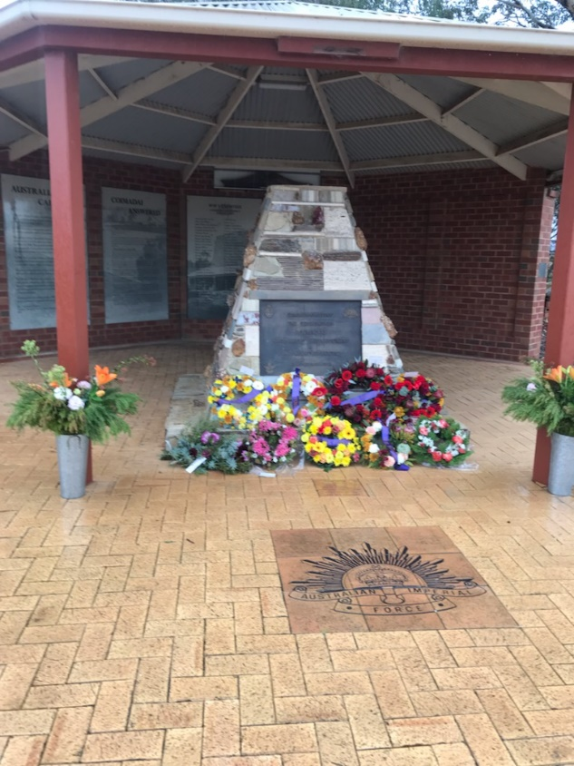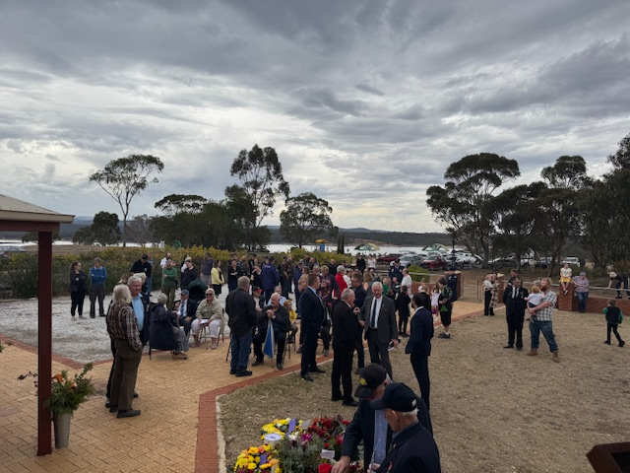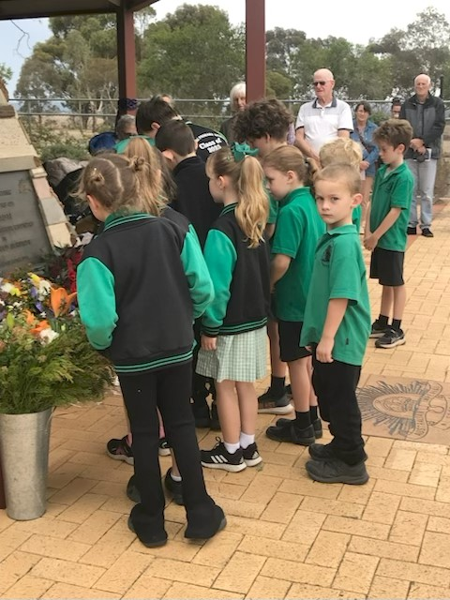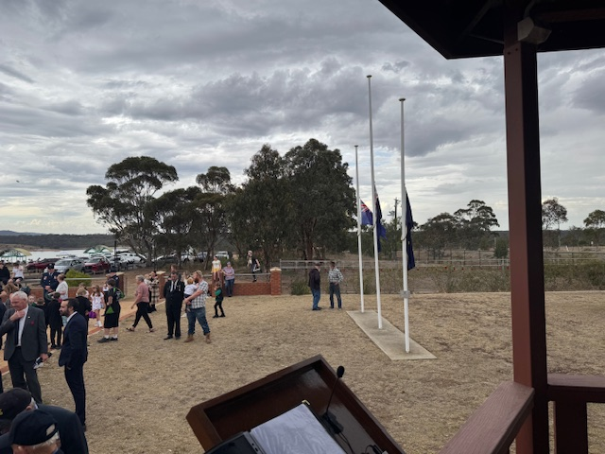

At the on-site meeting held with Ausnet, Southern Rural Water, Moorabool Council and our Association members, the Ausnet consultants put forward proposals to rearrange the Memorial Park to lessen the visual intrusion of the Transmission Line during ceremonies and to plant trees between the Park and the Transmission Line on the Southern and Eastern Sides. We indicated that we would raise these proposed measures with our members at the forthcoming annual meeting. Bearing in mind that the State Rivers and Water Supply Commission planted trees in 1967 to shield their quarry traffic from the Coimadai-Diggers Rest Road and that after 60 years these trees look like they were planted a couple of months ago.
The Association discussed the Ausnet suggestions at its last annual meeting and the members view was overwhelming in favour of “NO CHANGE”. These are a section of the minutes from that meeting
Discussion took place on proposals by AUSNET to re-align the Memorial Park so as to reduce the visual impact of the proposed towers and transmission line. The suggestions put forth by AUSNET included –

- Move the flagpoles towards the Northern fence and move the raised speakers building to the Northern side of the Memorial building holding the cairn REJECTED
- Plant trees along the Coimadai-Diggers Rest Road fence inside the Memorial Park to screen vision of the cables and towers REJECTED
- Plant trees along the Eastern fence of the SRW picnic ground to screen vision of the towers and cables crossing the reservoir OUT OF OUR CONTROL
- Underground the Powercor distribution line running North/South from near the toilet block. AGREED
- Relocate the Powercor distribution line running adjacent to the Avenue of Honour on the Southern side of Coimadai-Diggers Rest Road. NOT YET AGREED BY AUSNET BUT STRONGLY SUPPORTED BY US The proposed Eastern Link Diversion Road impacts 38 trees at the Western end of our Avenue which will require moving these poles by Vicroads at one end and AUSNET at the other end
- Relocate the SRW picnic ground and Coimadai Memorial Park some 100 metres or more on the SRW land including the toilet block, entrance roads etc, so as to not view the transmission line during ceremonies or picnics
- REJECTED OUT OF HAND

We are told that the proposed road realignment and roundabout at the Western end of the Coimadai-Diggers Rest Road has not yet been funded and therefore cannot be considered conjointly with the Transmission Line project, despite the fact that both projects are under the control of the Victorian Government and both impact severely the Coimadai Avenue of Honour. The following draft plan shows the proposed roadworks and when compared to the transmission tower locations shown on page 65 of the EES Map Book, the towers F57DL and F4307D seem to be on the same land as the realigned new road. Surely this cannot be allowed to happen and the two construction authorities are required to communicate with one another. In any event, both projects clash with the Powercor distribution line and perhaps there is some salvation for the Coimadai Avenue of Honour when the Powercor line has to be relocated.

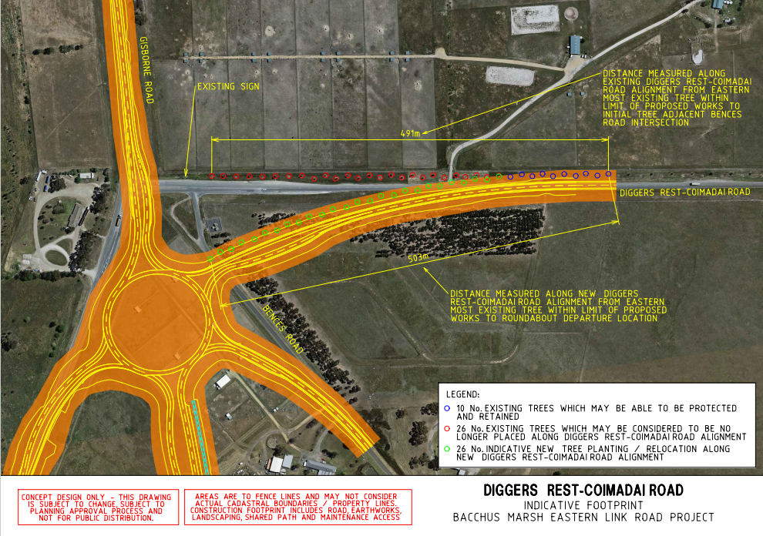
The effort by Coimadai citizens in volunteering for World War 1 was outstanding (129 volunteers from a census of 404). The effort by the current citizens of Coimadai in replacing the Avenue of Honour and building the Coimadai Memorial Park has also been outstanding. This full project is managed and maintained by the Association with some help from the Shire of Moorabool and Southern Rural Water Commission. The Avenue is at severe risk at being modified beyond comprehension by the two Government instrumentalities involved in these projects and the citizens of Coimadai plead for assistance to preserve this significant memorial. Having replanted the Avenue four times, moved the Memorial Cairn and constructed the Memorial Park, is surely enough impost on a small community that has provided so much over so many years. The route for the Transmission Line which runs parallel to The Coimadai Avenue of Honour for its full length and which overshadows visually the Coimadai Memorial Park because of its transgression over Merrimu Reservoir, surely does not have to go that way. To the people of Coimadai, this Park and Avenue are their “shrine” and would you run this line past the Melbourne Shrine of Remembrance. No you wouldn’t because of the significance and importance of the memorial. Such is the case in Coimadai and a further look at the planning or a better finance allocation could shift that section of the Transmission Line. It has taken more than 100 years to create a Memorial in Coimadai that is befitting the sacrifice made by our volunteers to the Great War. Is this Memorial worth saving and protecting for the future, yes we think so “at all costs”. We urge you to agree with our sentiments and do whatever you can to leave the Coimadai Avenue of Honour and Coimadai Memorial Park, intact and without interference. Please reflect on your opinion as if your ancestors were represented in this Memorial.

Ken McDonald
Chairman
Coimadai Avenue of Honour Restoration Association Inc

